TASK 11: PHISHING ATTACK SIMULATION & DETECTION

1. Project Overview
This lab demonstrates the technical workflow of a phishing attack by simulating a controlled campaign using GoPhish within a Kali Linux environment. The objective is to evaluate both the attacker’s methodology and the defensive strategies required to identify phishing indicators.
Key Objectives:
Understand how attackers design and deploy malicious email campaigns.
Observe victim interaction and credential harvesting in real-time.
Analyze red flags used for detection and prevention.
2
. Lab Environment & Tools
•
•
•
- Operating System: Kali Linux (Simulation environment)
- Framework: GoPhish (Open-source phishing simulation platform)
- SMTP Provider: Gmail (Via a dedicated test account: _{usert8068@gmail.com} )
- Security Control: App Passwords for secure SMTP access

3. Methodology & Implementation

3.1 Installation & Platform Setup
GoPhish was deployed on the Kali terminal using the following commands:
sudo apt update
wget https://github.com/gophish/gophish/releases/latest/download/gophish-v0.12.1-
linux-64bit.zip
unzip gophish-v0.12.1-linux-64bit.zip -d gophish_lab
cd gophish_lab chmod +x gophish
sudo ./gophish
The Admin Panel was accessed locally at _{https://localhost:3333} to manage the campaign phases.
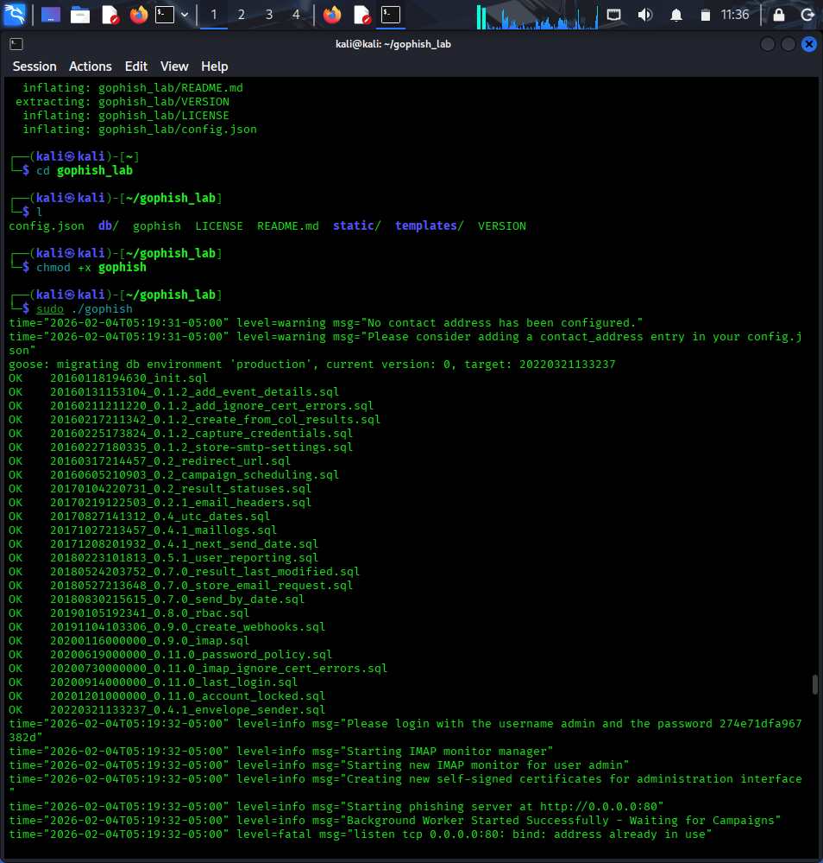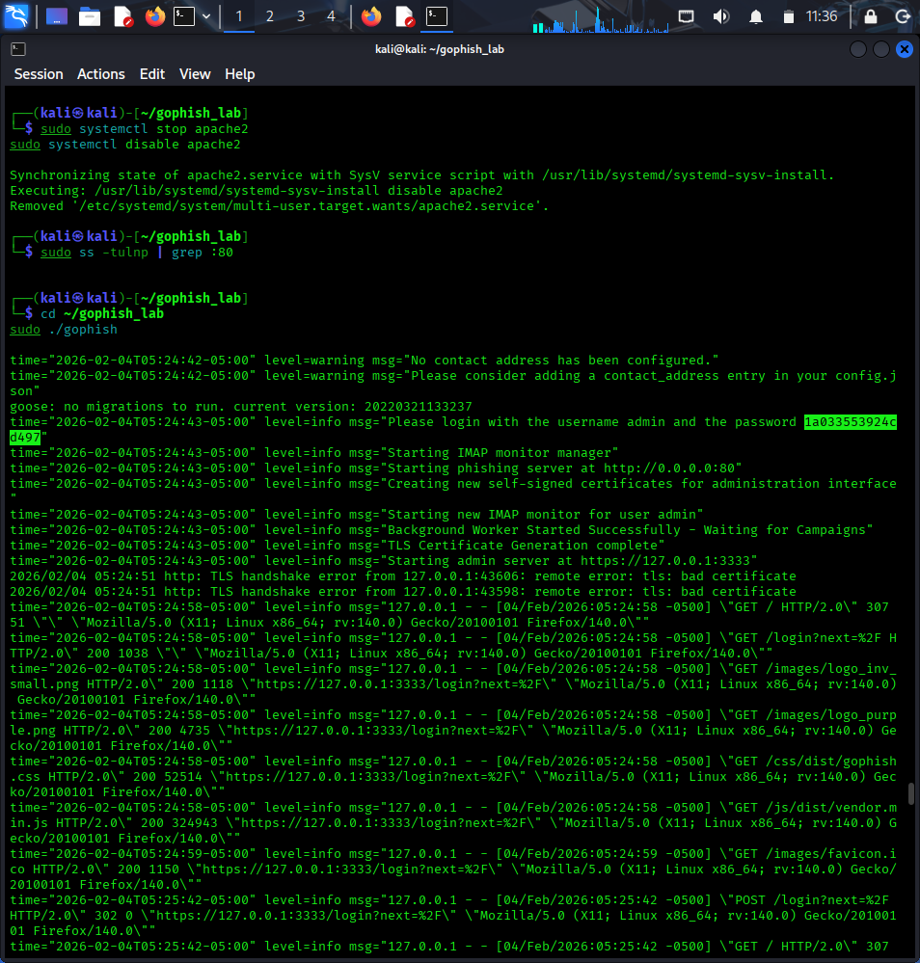

3.2 SMTP Configuration (Sending Profile)
Field | Value
Interface Type | SMTP
Host | smtp.gmail.com:587
Username | usert8068@gmail.com
Encryption | STARTTLS
From | IT Support <usert8068@gmail.com>

3.3 Phishing Assets Creation
Email Template (The Bait): A high-urgency email was designed notifying the user that their password was set to expire, containing a direct link to the capture page.
Landing Page (The Hook): A fake "Company Webmail Login" page was coded in HTML. Data capture was enabled to intercept submitted usernames and passwords, after which victims were redirected to
google.com to minimize suspicion.
<html>
<body>
<h2>Company Webmail Login</h2>
<form method="POST">
Username: <input name="username"><br>
Password: <input name="password" type="password"><br>
<input type="submit" value="Login">
</form>
</body>
</html>

4. Results & Observations
Once the campaign was launched targeting the lab email group, the GoPhish Dashboard recorded the following telemetry:
- Timeline Tracking: Timestamp of when the email was opened and link clicked.
- Credential Harvest: Captured usernames and passwords in plain text.
- Device Metadata: IP addresses and browser signatures of the interacting clients.
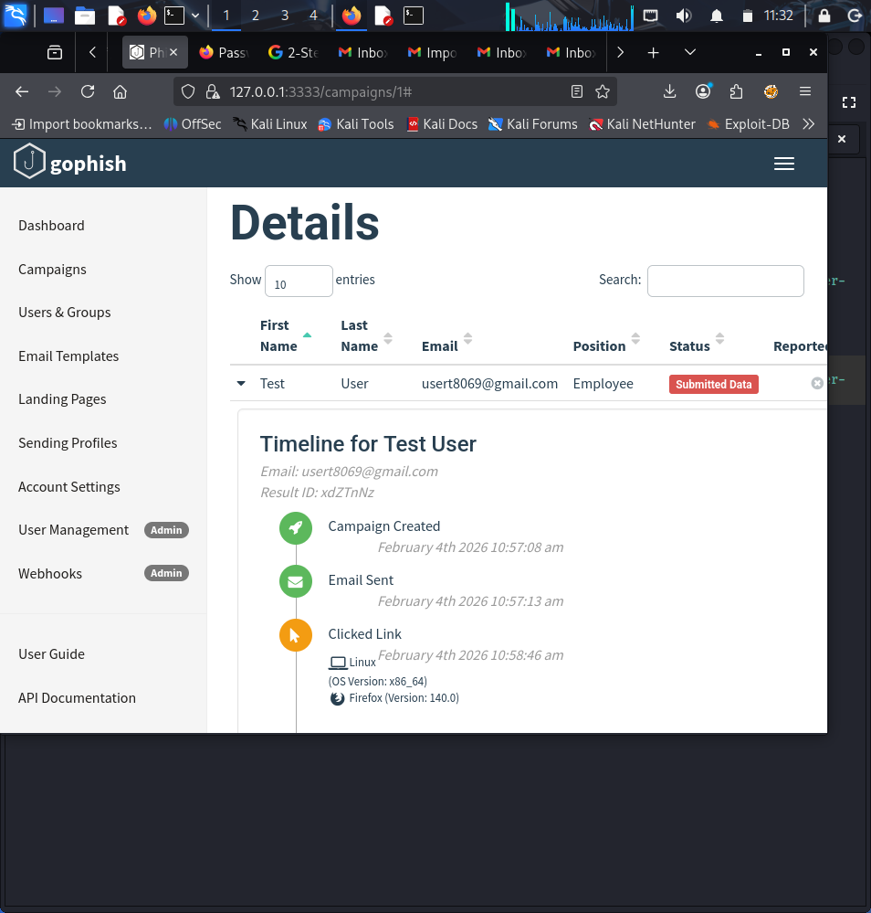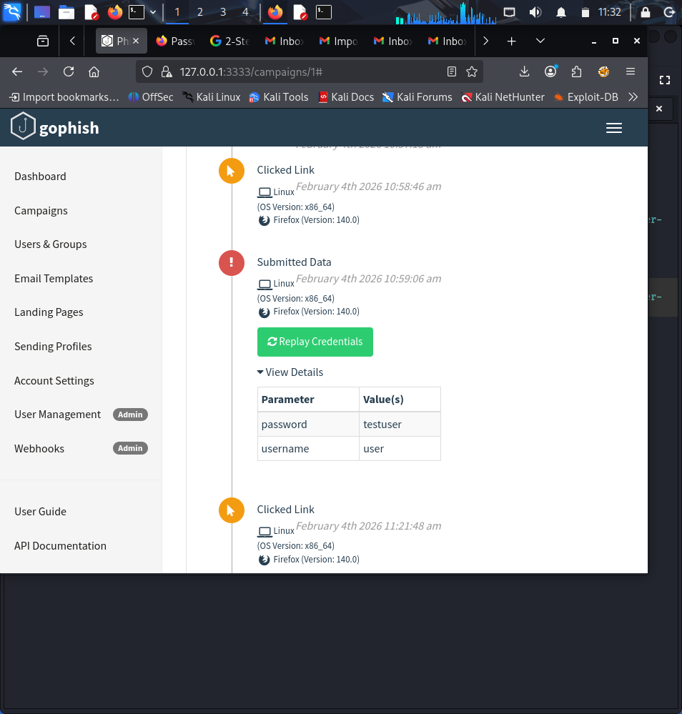

5. Analysis of Phishing Indicators (Blue Team Perspective)
Indicator | Description / Reason for Suspicion
Urgent Language | Uses "expires today" to create panic and bypass critical thinking.
Generic Greeting | Fails to use the user's specific name, often a sign of mass-mailing.
Unknown Domain | The link points to a Kali IP or unauthorized domain rather than the official company portal.
Credential Request | Legitimate services rarely request login details via unsolicited email links.

6. Prevention & Defense Strategies
- User Awareness: Training staff to hover over links and check the actual URL destination.
- Email Authentication: Implementing SPF, DKIM, and DMARC to prevent domain spoofing.
- Multi-Factor Authentication (MFA): Ensuring that even if credentials are stolen, the attacker cannot gain access.
- Reporting Protocols: Encouraging the use of "Report Phishing" buttons to alert the security team immediately.

7. Conclusion
This simulation provided practical insight into the lifecycle of a phishing attack. By acting as the attacker, we gain a clearer understanding of the vulnerabilities targeted. This experience reinforces the importance of layered defense—combining technical controls like MFA with human-centric training to secure the organization.

